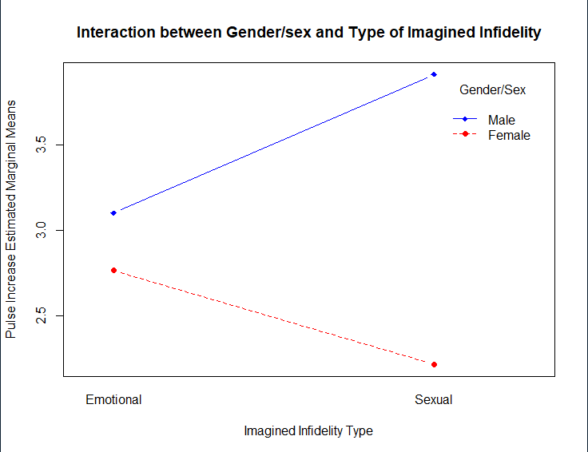

A 2 x 2 factorial ANOVA was employed to determine the effectsof gender/sex and type of imagined infidelity on participants’ amount of increase in heart rate.A .05 criterion of statistical significance was employed for all tests. The main effect of gender was significant, indicating that men have a larger change in pulse rate,*F* (1, 379) **=** 6.445, *p*=.01, *η2*=.017, however type of imagined infidelity was not significant, F(1, 379) = 1.57**,** p= .749,*η2*< .001. Their interaction was not significant,*F* (1, 379) **=** 44.38**,** p= .089,*η2*=.008. Simple main effect of gender-male was not significant, *F* (1, 189) = 2.025, *p*=.156, *η2*=.011, and simple main effect of gender-female was also not significant, *F* (1,189) = .966, *p*=.327, *η2*=.005. Overall, men had a larger change in pulse rate (*M*=3.504) than women (*M*=2.49).